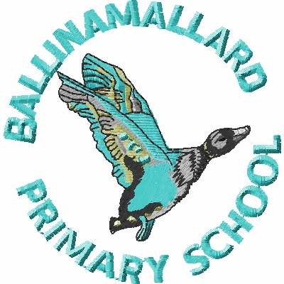
BALLINAMALLARD PRIMARY & COMMUNITY NURSERY SCHOOL
19 Baragh Road Ballinamallard Co. Fermanagh BT94 2NY
Phone: 028 6638 8262
E-mail: info@ballinamallardps.enniskillen.ni.sch.uk
Website: www.ballinamallardps.com


November 2023 Dinner Amount

If you wish to pay for dinner for the month of November 2023, the amount will be £36.40
(14 days @ £2.60) from Tues 7 Nov – Fri 24 Nov 2023. (Last Friday in month) Please pay for dinners at the beginning of the week or month.
REMINDER – If paying by cheque for school dinners or school milk, PLEASE MAKE CHEQUES PAYABLE TO EA Western Region. All monies in a named envelope at the beginning of the week or month please.

2-3 Club for Years 1 & 2
If your child is staying for afternoon 2-3 club, it is important to book and pay for this on a Monday. Please ensure to write the days that your child is staying on the front of the envelope. (All monies in a named envelope)

Please note
School will close at 12.30pm this Friday (27 Oct) to accommodate the Parent / Teacher meetings.
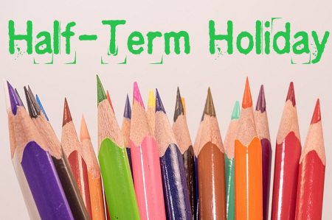
HOLIDAY DATES

Autumn Term 2023
Last day of term | School Open | Friday 27 October 2023 (12.30pm closure)
Half term | School Closed | Mon 30 Oct – Fri 3 Nov 2023 (Inclusive)
Staff Training | School Closed | Mon 6 Nov 2023
Last day of term | School Open | Thurs 21 December 2023 (12.30pm closure)

