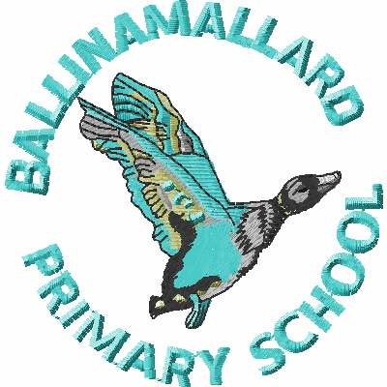
BALLINAMALLARD PRIMARY & COMMUNITY NURSERY SCHOOL
19 Baragh Road Ballinamallard Co. Fermanagh BT94 2NY
Phone: 028 6638 8262
E-mail: info@ballinamallardps.enniskillen.ni.sch.uk
Website: www.ballinamallardps.com


December 2023 Dinner Amount

If you wish to pay for dinner for the month of December 2023, the amount will be £49.40 (19 days @ £2.60) from Mon 27 Nov – Thurs 21 Dec 2023. (Last day in term) Please pay for dinners at the beginning of the week or month.
REMINDER – If paying by cheque for school dinners or school milk, PLEASE MAKE CHEQUES PAYABLE TO EA Western Region. All monies in a named envelope at the beginning of the week or month please.

Change of December Menu

Thursday 14 December | Thursday 21 December
Christmas Dinner  Roast Turkey & Stuffing  Cocktail Sausages  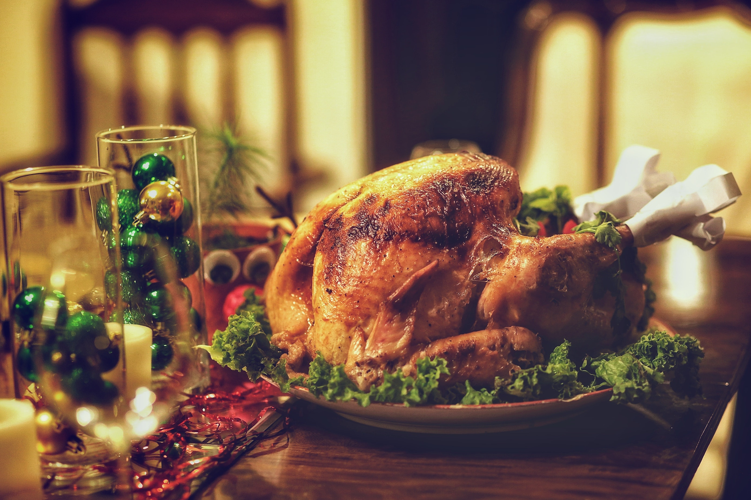  Carrots / Sweet Corn  Mashed / Roast Potatoes  Gravy  Ice Cream  Orange Juice | Last Day of Term  Chips & Sausage in a box    Christmas Biscuit  Orange Juice

Afternoon Clubs (2-3pm & Homework Club3-5.30pm)
If your child is staying for Afternoon 2-3pm club or Homework club 3-5.30pm, it is important to book and pay for this on a Monday. Please ensure to write the days that your child is staying on the front of the envelope. (All monies in a named envelope please)

Closing Days – Christmas Holidays

The school will be closed on the following days: -

Thursday 21 December – School will close at 12.30pm

Friday 22 Dec – Wed 3 Jan 2024 (Inc) - Christmas Holidays
Thurs 4 Jan 2024 – School Closed - Staff Training Day

Children return to school on Friday 5 January 2024.

