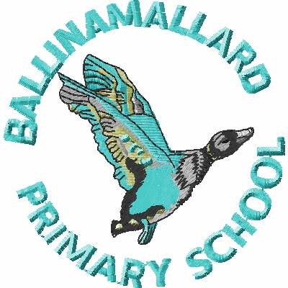
BALLINAMALLARD PRIMARY & COMMUNITY NURSERY SCHOOL
19 Baragh Road Ballinamallard Co. Fermanagh BT94 2NY
Phone: 028 6638 8262
E-mail: info@ballinamallardps.enniskillen.ni.sch.uk

Please note change of menu for Thurs 14 Dec 2023

Thursday 14 Dec 2023
Cheese Pizza
Italian Chicken Tomato Pasta Bake
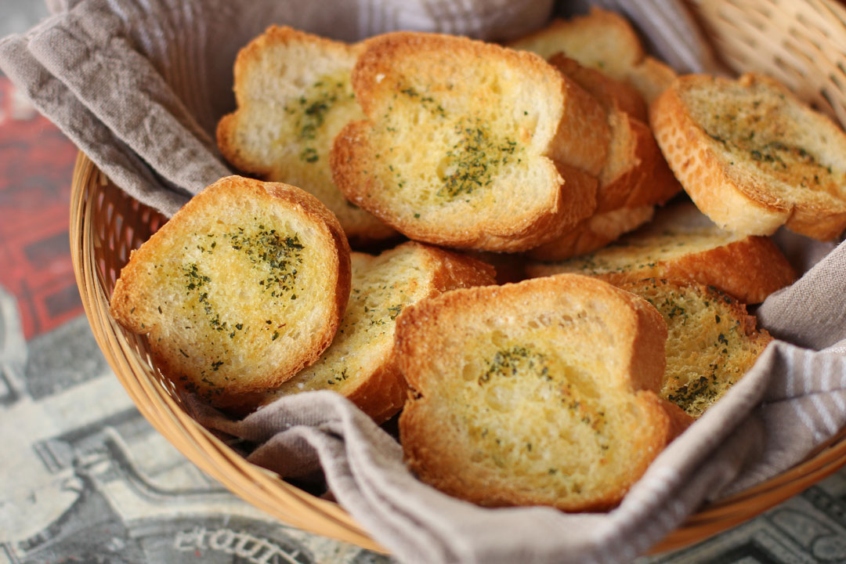
Garlic Bread
Peas
Chipped Potatoes
Chocolate Cake
Custard

Reminder
Dinners - £2.60 per day - £13.00 per week.

Please remember to send dinner money with your child at the beginning of each week. All monies in a named envelope please.

HOLIDAY DATES

Autumn Term 2023
Last day of term | School Open | Thurs 21 December 2023 (12.30pm closure)
Spring Term 2024
Staff Training | School Closed | Thurs 4 Jan 2024
First day of term | School Open | Fri 5 Jan 2024
Half Term | School Closed | Thurs 15, Fri 16, Mon 19 Feb 2024
Staff Training | School Closed | Mon 18 March 2024
Last day of term | School Open | Fri 22 March 2024 (12.30pm closure)
Staff Training | School Closed | Mon 25 March 2024

