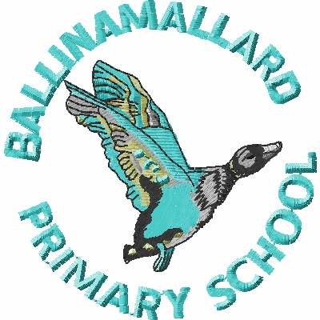
BALLINAMALLARD PRIMARY & COMMUNITY NURSERY SCHOOL
19 Baragh Road Ballinamallard Co. Fermanagh BT94 2NY
Phone: 028 6638 8262
E-mail: info@ballinamallardps.enniskillen.ni.sch.uk
Website: www.ballinamallardps.com


March 2024 Dinner Amount

If you wish to pay for dinner for the month of March 2024, the amount will be £49.40 (19 days @ £2.60) from Mon 26 February – Fri 22 March 2024. (Last day of term) Please pay at the beginning of the week or month.
REMINDER – If paying by cheque for school dinners or school milk, PLEASE MAKE CHEQUES PAYABLE TO EA Western Region. All monies in a named envelope at the beginning of the week or month please.

Closing Days – Bank Holiday & Staff Training Day

The school will be closed on the following days:-
Spring Term 2024
Staff Training | School Closed | Mon 18 March 2024
Last day of term | School Open | Fri 22 March 2024 (12.30pm closure)
Staff Training | School Closed | Mon 25 March 2024
Summer Term 2024
First day of term | School Open | Mon 8 April 2024
Bank Holiday | School Closed | Mon 6 May 2024
Bank Holiday | School Closed | Mon 27 May 2024
Staff Training | School Closed | Mon 10 June 2024
Last day of term | School Open | Fri 28 June (12.30pm closure)

