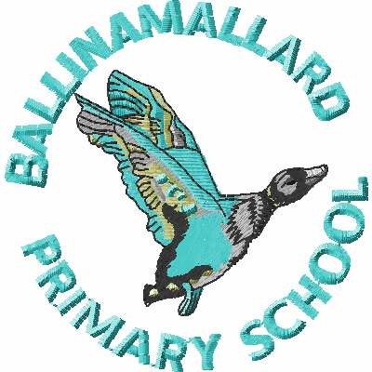
BALLINAMALLARD PRIMARY & COMMUNITY NURSERY SCHOOL
19 Baragh Road Ballinamallard Co. Fermanagh BT94 2NY
Phone: 028 6638 8262
E-mail: info@ballinamallardps.enniskillen.ni.sch.uk
Website: www.ballinamallardps.com


October 2024 Dinner Amount

If you wish to pay for dinner for the month of Oct 2024, the amount will be £54.60 (21 days @ £2.60) from
Mon 30 Sept – Mon 28 Oct 2024. (Last day in term) Please pay at the beginning of the week or month.
REMINDER – If paying by cheque for school dinners or school milk, PLEASE MAKE CHEQUES PAYABLE TO EA Western Region. All monies in a named envelope at the beginning of the week or month please.

Closing Days – Half Term & Staff Training Day

The school will be closed on the following days:-

Autumn Term 2024
First day of term | School Open | Mon 2 Sept 2024
Half term | School Closed | Wed 30 Oct – Fri 1 Nov 2024 (Inclusive)
Staff Training | School Closed | Mon 4 Nov 2024
Last day of term | School Open | Fri 20 December 2024 (12.00pm closure) (No School Dinners/Lunch)

First day of term for children 2025 | School Open | Tues 7 Jan 2025

