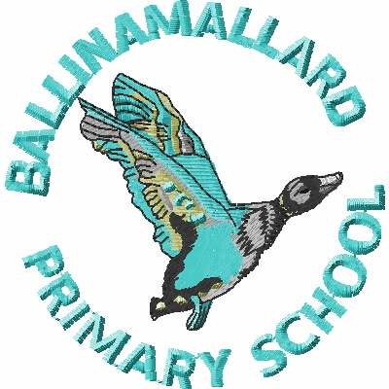
BALLINAMALLARD PRIMARY & COMMUNITY NURSERY SCHOOL
19 Baragh Road Ballinamallard Co. Fermanagh BT94 2NY
Phone: 028 6638 8262
E-mail: info@ballinamallardps.enniskillen.ni.sch.uk
Website: www.ballinamallardps.com


November 2024 Dinner Amount

If you wish to pay for dinner for the month of November 2024, the amount will be £49.40
(19 days @ £2.60) from Tues 5 Nov – Fri 29 Nov 2024. (Last Friday in month) Please pay for dinners at the beginning of the week or month.
REMINDER – If paying by cheque for school dinners or school milk, PLEASE MAKE CHEQUES PAYABLE TO EA Western Region. All monies in a named envelope at the beginning of the week or month please.
2-3 Club for Years 1 & 2 & Homework Club for Years 1-7
If your child is staying for afternoon 2-3 club and/or Homework Club, it is important to book and pay for this on a Monday. Please ensure to write the days that your child is staying on the front of the envelope. (All monies in a named envelope please)

Please note
School will close at 12 noon on Tuesday 29 October to accommodate the Parent / Teacher meetings.
There is NO Breakfast Club / Snack / School Dinner
on this day.
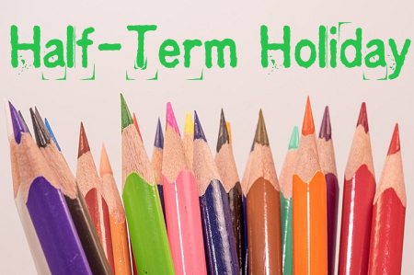
HOLIDAY DATES

Autumn Term 2024
Last day of term | School Open | Tuesday 29 October 2024 (12 noon closure)
Half term | School Closed | Wed 30 Oct – Fri 3 Nov 2024 (Inclusive)
Staff Training | School Closed | Mon 4 Nov 2024
 | School Open | Tuesday 5 Nov 2024
Last day of term | School Open | Fri 20 December 2024 (12.00 noon closure) (No School Dinners/Lunch)

